UNIT IV
Computer Folder Structure Using a General Tree

Problem Statement
Model a computer folder structure as a general tree. Compute the degree, height, and depth of a given nodeand determine the total number of leaf nodes.

Objectives
- Understand the General Tree data structure.
- Represent folders and files hierarchically.
- Search for a specific node.
- Calculate degree, height, and depth.
- Count the total number of leaf nodes.
- Implement tree operations using C++.

Tree Structure

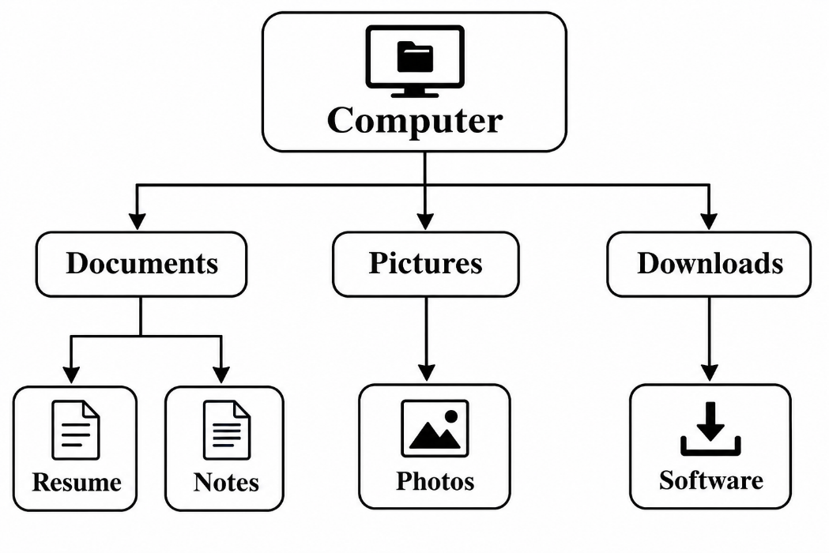
Definitions
- Degree: Number of direct children of a node.
- Height: Longest downward path from a node to a leaf.
- Depth: Number of edges from the root to a node.
- Leaf Node: A node with no children.
- Number of Leaves: Total leaf nodes in the tree.

Algorithm
1. Start the program.
2. Create the root node.
3. Create folder and file nodes.
4. Connect the nodes to form a tree.
5. Display the tree structure.
6. Accept a node name from the user.
7. Search for the selected node.
8. Calculate its degree, height, and depth.
9. Count all leaf nodes.
10. Display the results.
11. Release allocated memory.
12. Stop the program.

Flowchart
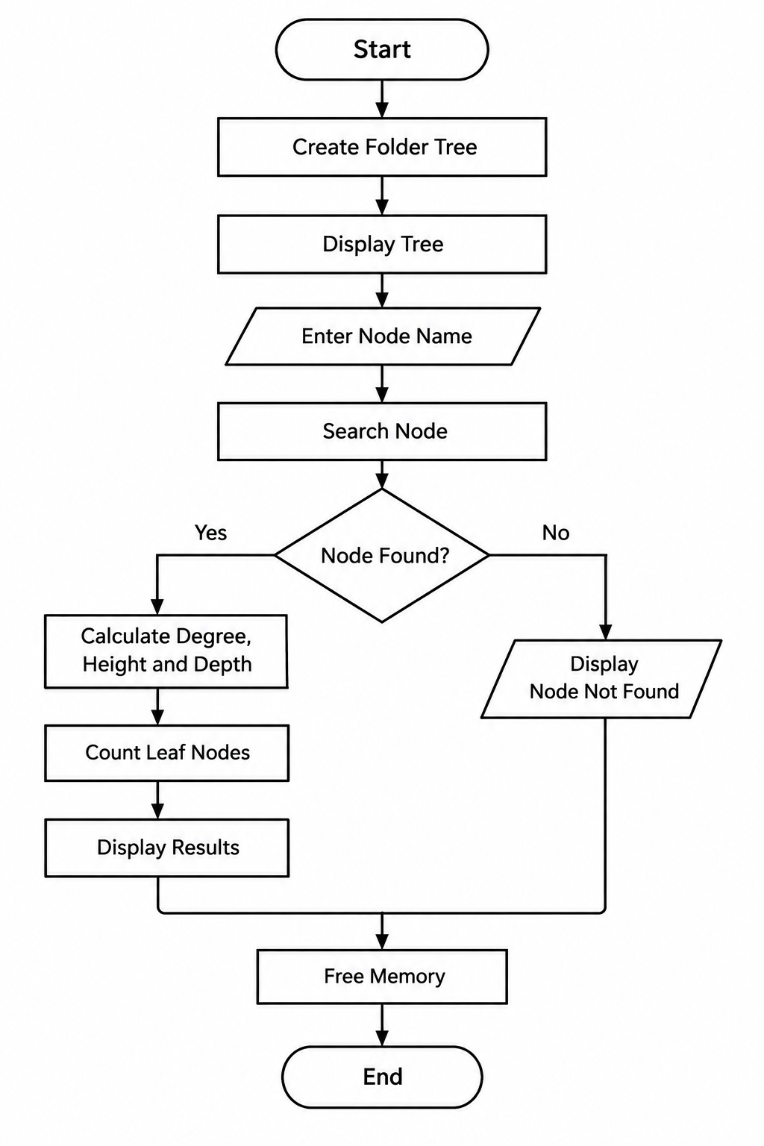
Sample Input
Enter a folder/file name to analyze: Documents

Sample Output
Node name : Documents
Degree : 2
Height : 1
Depth : 1
Total leaf nodes: 4

Technologies Used
- Programming Language: C++
- Data Structure: General Tree
- Concepts: Recursion, Pointers, Dynamic Memory Allocation
- IDE: Dev-C++

Conclusion
This project demonstrates the application of a General Tree to represent a computer folder hierarchy. It uses recursive functions to calculate degree, height, depth, and the total number of leaf nodes. The project improves understanding of tree data structures and their applications in C++.

